How to use Putty

1. Create instance
2. Create key/pair in AWS for the compute instance
   1. Will automatically download the “PuTTY Private Key File” in the Downloads folder on local machine
3. Move PuTTY (the Windows installer package file) & the “PuTTY Private Key File to the same directory on local machine
4. Open Putty
5. Put in IP address
   1. From AWS:
      1. 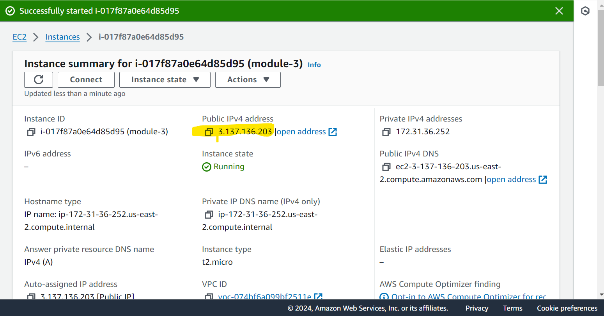
6. Select Connection/SSH/Auth/Credentials
7. Browse and select the link to the “PuTTY Private Key File”
8. Will prompt you to enter something - it’s “ubuntu”
9. Now you have your command line